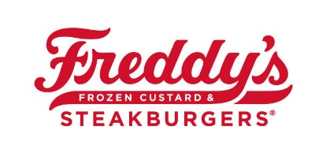
DIY Sundae Kits

Store Instructions
How a Guest Will Order – Via Phone or In-Store or Drive Thru

Cost of DIY Sundae Kit - $19.99 plus tax --- Ring in as Open Custard

Store Instructions – Each kit will include:

- (1) QT of Freddy’s Premium Vanilla, Chocolate or Half-and-Half Custard
- 6oz of TOPPING 1 (in an 8oz mini cup)
- 6oz of TOPPING 2 (in an 8oz mini cup)
- 6oz of TOPPING 3 (in an 8oz mini cup)
- (6) Maraschino Cherries (in an 8oz cup)
- (1) can of Whipped Cream
- (6) 8oz Freddy’s Containers (Mini Cups)
- (6) Red Freddy’s Spoons
- (10) Napkins
- DIY Kit Instructions
- Allergen List
- Ingredient List

The DIY Kit should be packaged in (2) Bags:
- Items #1-6 – Place in a 20LB Freddy’s Bag
- Items #7-12 – Place in a 12LB Freddy’s Bag
- Seal Each Bag with a Freddy’s Delivery Sticker
- Utilize Guest Order Form to ensure Accuracy on Order
- Ring in as Open Custard ($19.99) when the Guest Arrives
- Label with Guest’s Name via Delivery Mode (117 on Terminal) for Carry Out
- Ring in normally if through DT

Best Practices
- Additional Toppings may be ordered for $2.00 each.
- Whipped topping should be sourced from Hy-Vee for cost + size.
- Quarts should be Frozen Hard unless Fresh is Requested by Guest.
- Custard Quarts should be kept in freezer until picked up by Guest.
- Items 2-6 can be Pre-Packaged and Placed in Walk-In Cooler.
- Sauces (Hot Fudge, Caramel, Peanut Butter etc.) should be packaged like any other topping option.
- Consider stapling a Flyer to 2nd Bag w/ Rewards Program, Delivery Advertisement, etc.
- Consider placing in a GM Business Card with a “Thank You” and offer to contact us if they have questions.
- Be sure to encourage them to “Share” their sundaes on Social Media

